Creating Cloud Machines

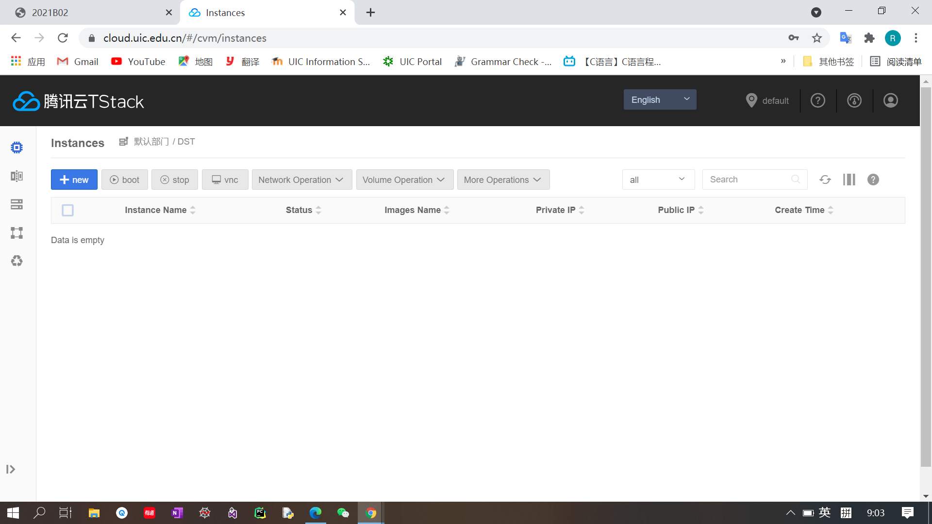

1. Log in the UIC cloud click ‘+new’ in the upper bar.

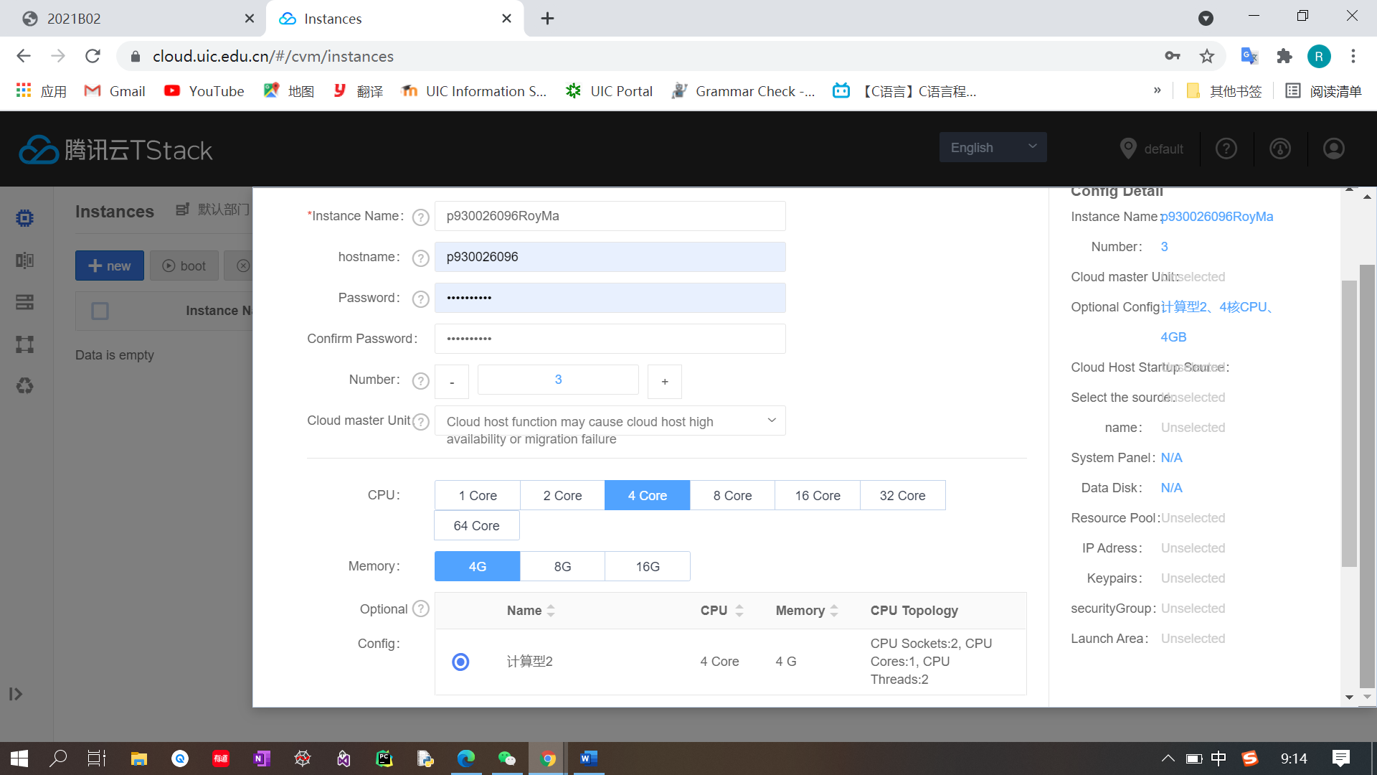

1. Create three new instances (setting: 4C/4G) and click next step.

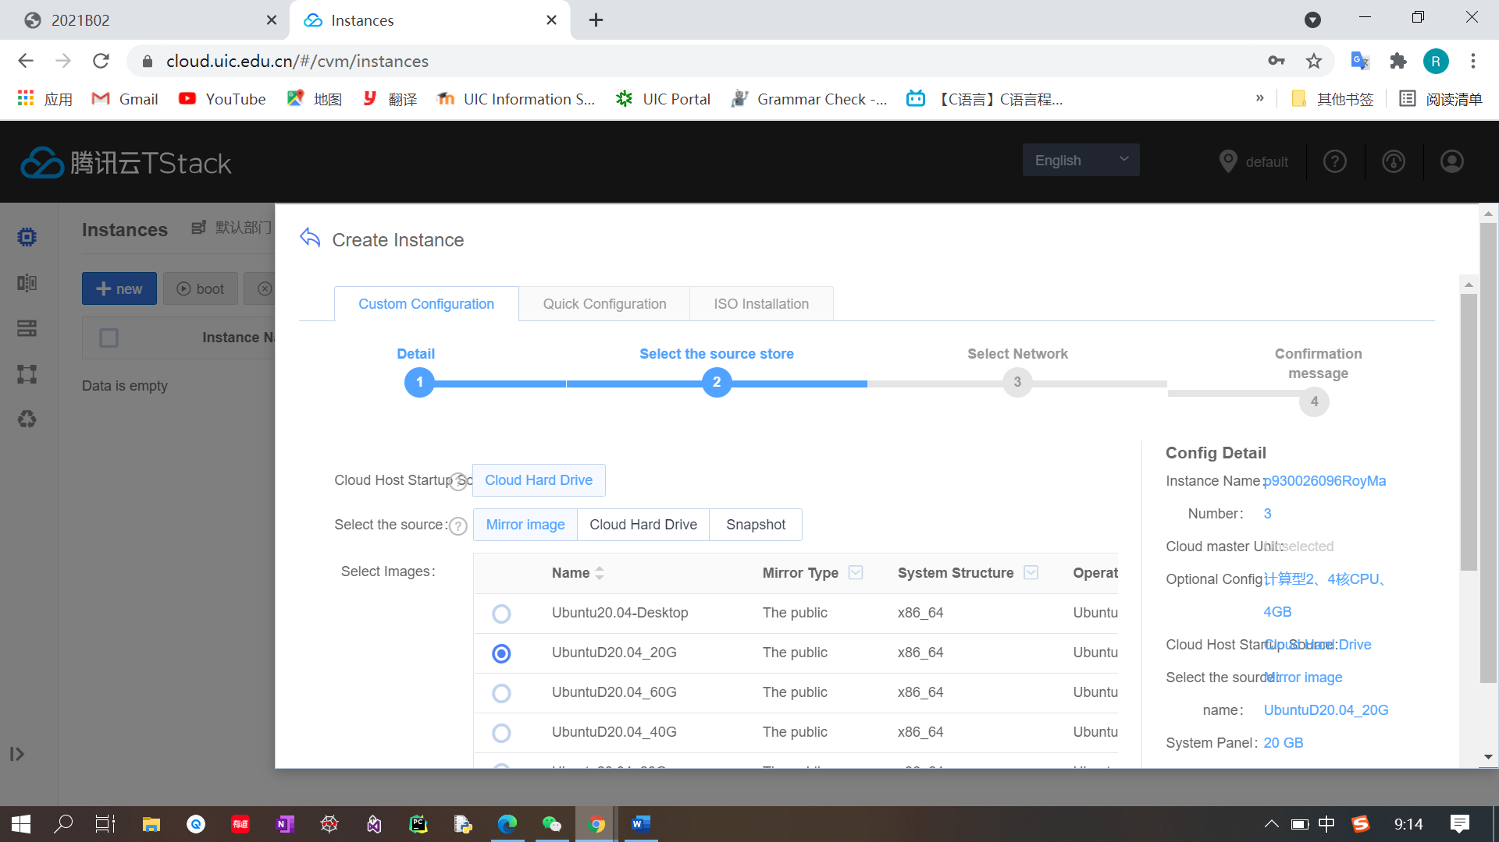

1. Choose UbuntuD20.04_20G and click next step.

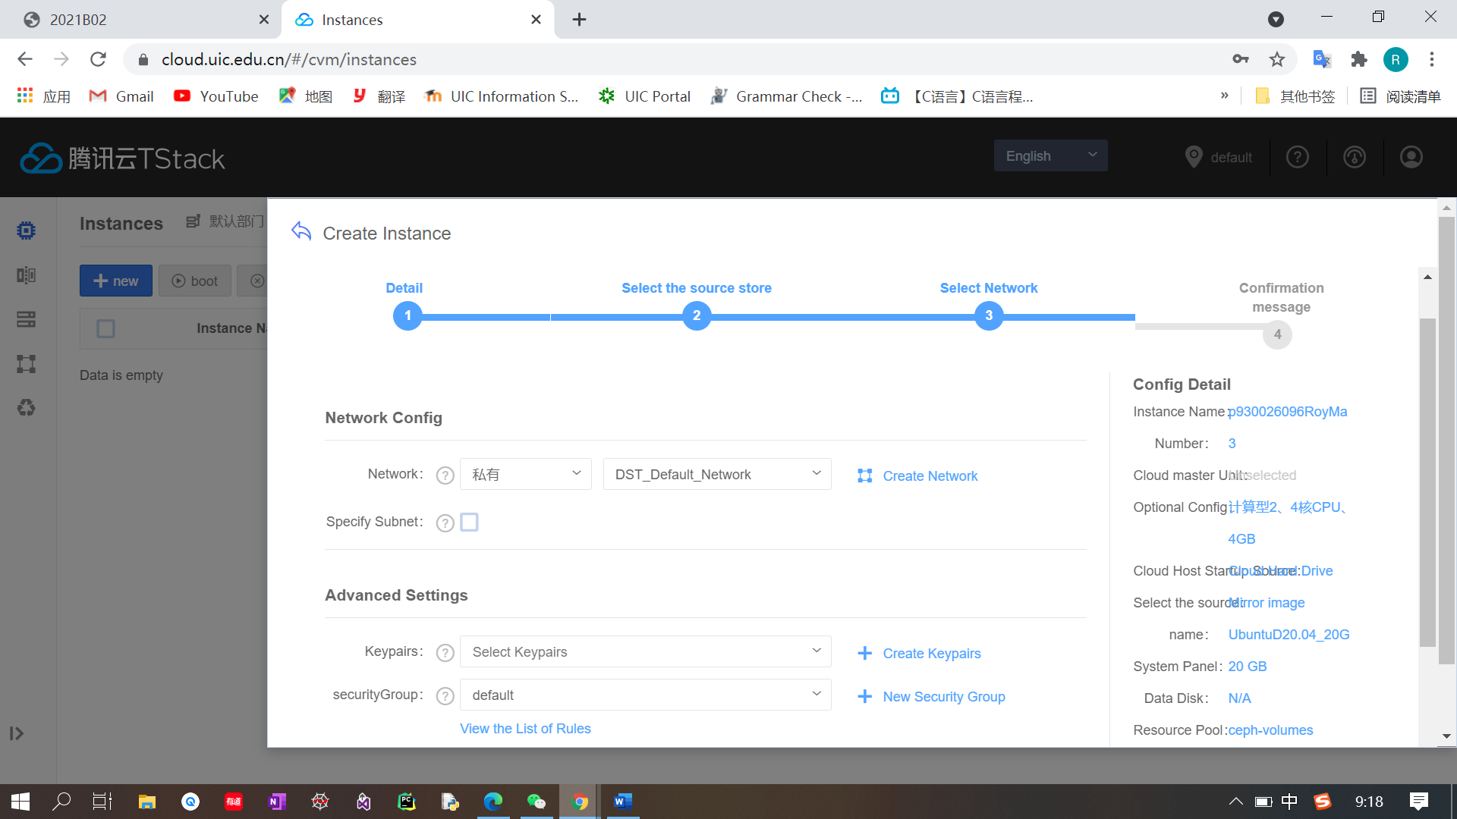

1. All default setting and click next step

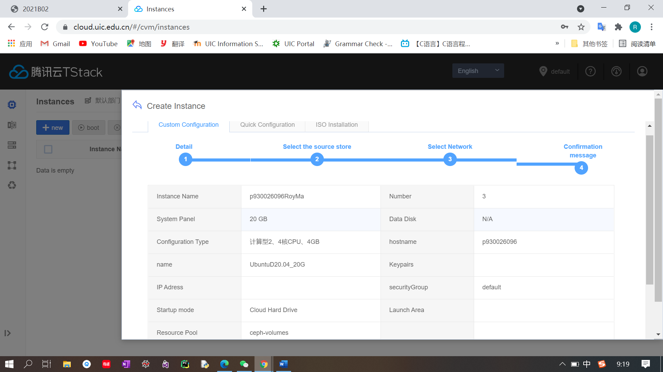

1. View our setting and if everything is Ok, then click create instance.

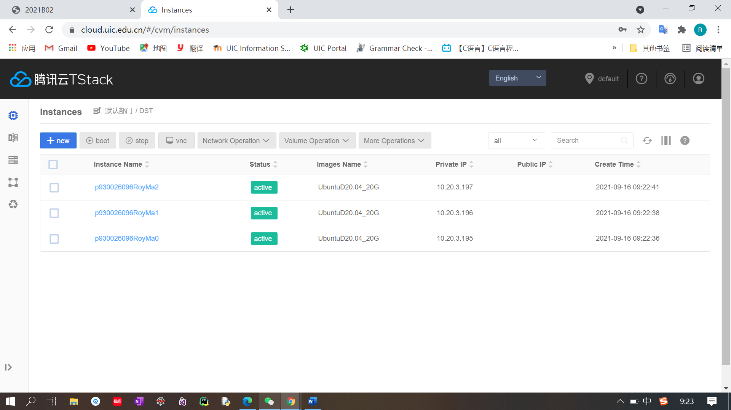

1. Wait 1-2 minutes until all the status is green.

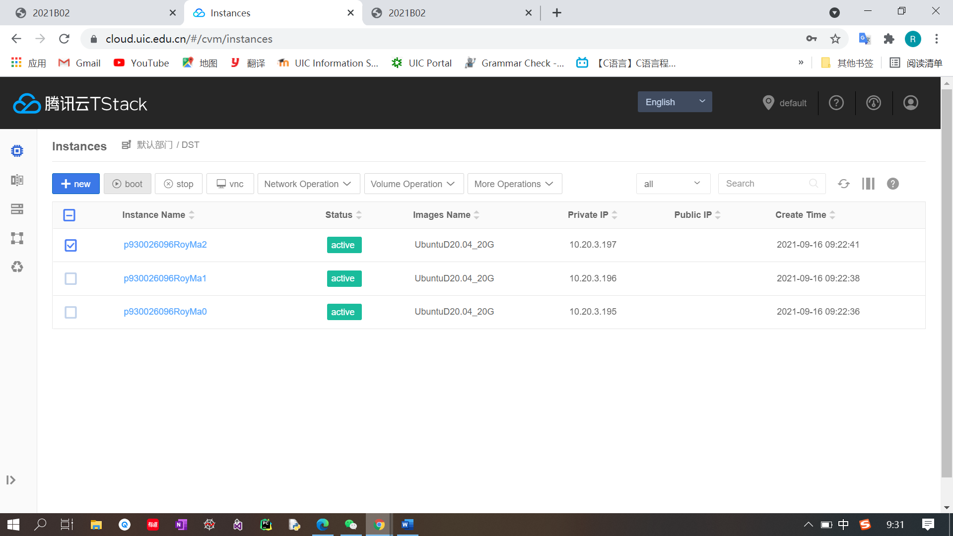

1. Choose the first cloud instance and click vnc in the upper bar.

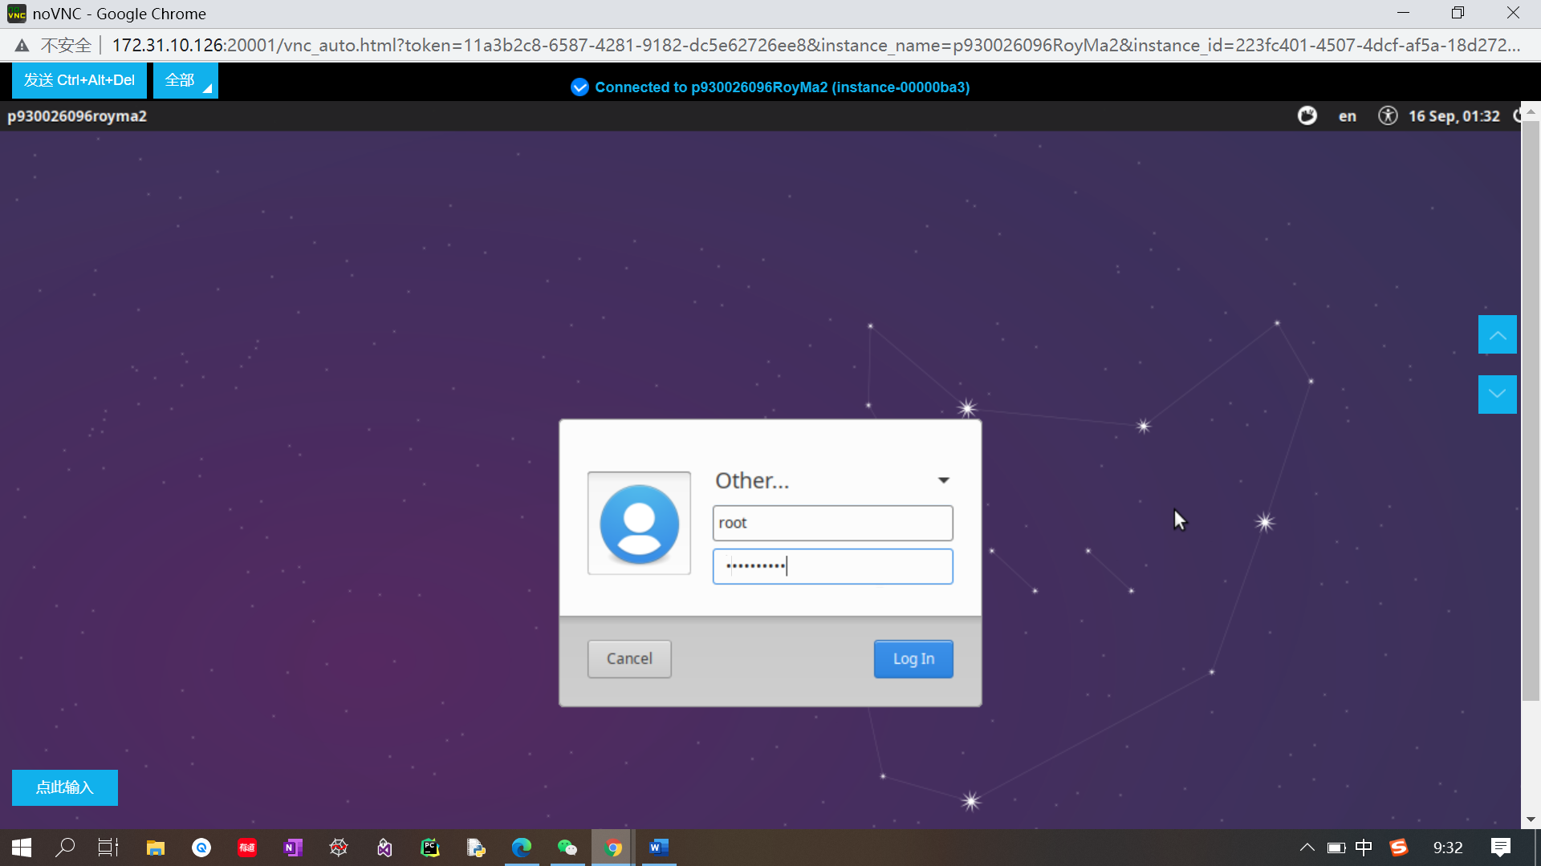

1. Choose other and enter name: root, and passwd.

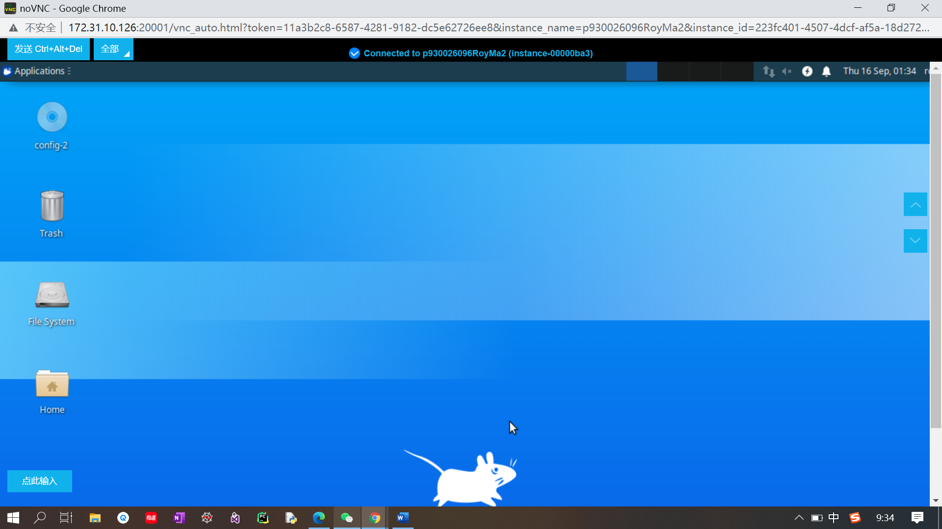

1. After click log in, we enter such interface.

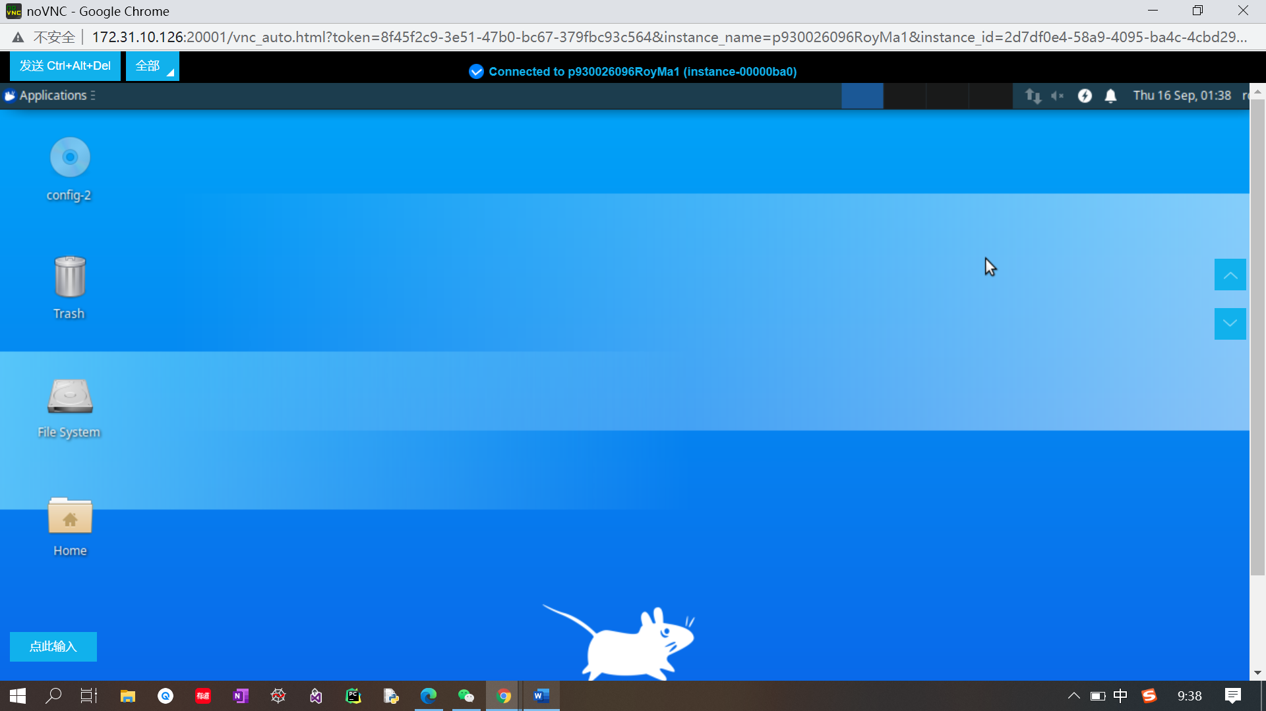

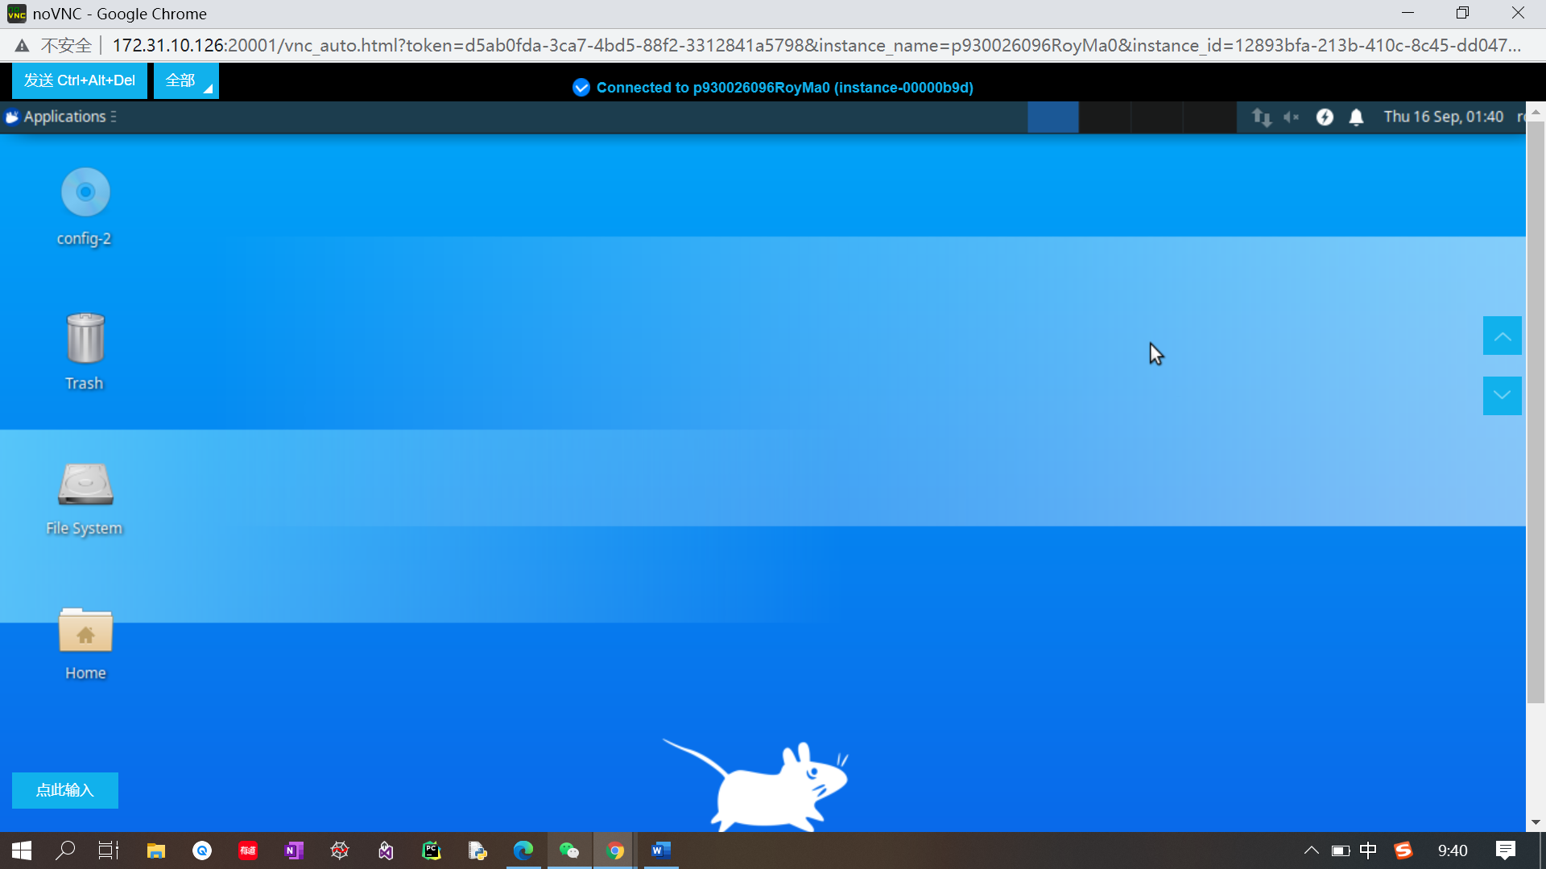

1. Apply the processes of 7-9 to the rest cloud instances so that you can access those instances.